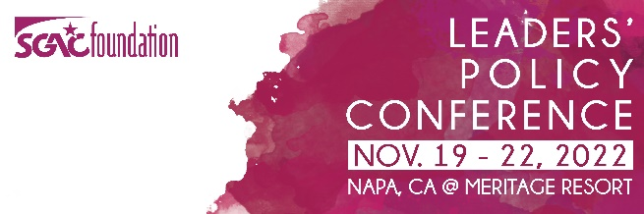

Saturday – November 19th
11:00AM - 2:30PM Advanced Certificate Session (Salon AK)
Credit Competency: Managing the GR Function / Leadership – Pre-requisite: Graduate of Professional Cert. Program
Credit: Managing the GR Function/Leadership
12:00PM – 5:00PM Registration Desk Open (Carneros Pre-function)
Thank you to Serlin Haley for sponsoring the Napa Valley Welcome Guidebooks.

3:00PM – 5:00PM Opening Remarks/Welcome and General Session (Salon B-J)
Thank you to McGuireWoods for sponsoring the Conference WIFI

5:30PM– 6:30PM Honor Circle Reception with Legislators -Honor Circle Members and Legislators Only
(Vintners Room)

6:00PM – 8:30PM Dinner on Property (Oakville Terrace/Lawn)
Thank you to The Carpet and Rug Institute for sponsoring the Red Carpet Welcome and to Lexis Nexis State Net for sponsoring the Reception.

Sunday – November 20th
9:00AM –1:00PM Registration Desk Open (Carneros Pre-function)

9:00AM – 10:00AM General Session: Monica Lewinsky (Salon B - J)

10:00AM – 10:15AM Break (Carneros Pre-function)
Thank you to Quorum for sponsoring the Beverage Break.

10:15AM – 11:15AM Concurrent Breakout Sessions

Cybersecurity, Modernization, Innovation in Technology (Salons 7 – 10)

State Supreme Courts Role in the Legislative Process (Salons 1-2)

11:15AM – 11:30AM Break (Carneros Pre-function)

11:30AM – 12:30PM Concurrent Breakout Sessions

The Travel Industry and the Impact on States (Salons 1-2)

Financial Literacy: Helping Prepare the Next Generation for Financial Success in Times
Of Economic Uncertainty (Salons 7 – 10)

1:00PM Afternoon / Evening Free / Optional Social Activities
Thank you to ATSSA for sponsoring the Social Event Transportation.

8:00PM – 12:00AM After Dinner at Crush Bowling Alley
Thank you to NBWA for sponsoring Beers and Bowling.

Monday – November 21st
8:00AM – 9:00AM Breakfast Available (Oakville Terrace)
Thank you to Sazerac for sponsoring the Bloody Mary Gift Bags.

9:00AM – 10:00AM Concurrent Breakout Sessions

What’s Next for Consumer Data Privacy (Salons 1-2)

Equity in Digital Literacy: Bridging the Digital Divide (Salons 7 – 10)

10:00AM – 10:15AM Break (Carneros Pre-function)

10:15AM – 11:15AM Concurrent Breakout Sessions

Workforce Development (Salons 1-2)

Exploring Telehealth: Capabilities and Limitations (Salons 7 – 10)

11:15AM – 11:30AM Break (Carneros Pre-function)

11:30PM – 12:30PM General Session: Mark McKinnon (Salon B-J)

1:00PM Afternoon Free

5:00PM – 6:30PM General Session: Leadership and Wine RSVP TO SGAC STAFF REQUIRED (Wine Cave)

6:30PM – 8:30PM Dinner on Property (Vineyard Terrace)
Thank you to Stateside for sponsoring the Reception Wine Sticks.

Tuesday – November 22nd
8:30AM – 10:00AM Grab and Go Breakfast (Oakville Terrace)

